Modeling 10-ness using Technology in the Elementary Classrooms

Jennifer Suh
Assistant Professor of Mathematics Education
George Mason University

Padmanabhan Seshaiyer
Associate Professor of Mathematical Sciences
George Mason University

Modeling 10-ness using Technology in the Elementary Classrooms
Developing the concept of 10-ness is foundational in understanding place value and our decimal number system. This article describes focused learning experiences designed to develop teachers’ technology knowledge in teaching mathematics focused on number sense with the use on-line applets. We explored mathematics concepts and various related models and representations using technology through an activity called Modeling Mathematics through Tech-Knowledgy in both a pre-service elementary methods course and an in-service teacher content course focused on Numbers. This practiced-based activity was based on the idea of developing teachers’ Technology Pedagogical Content Knowledge, TPACK, (Koehler and Mishra, 2008) which include three specific knowledge domains: 1) technology; 2) mathematics content; and 3) pedagogy. Koehler & Mishra (2008) describe TPACK, as “the basis of good teaching with technology which requires an understanding of the representation of concepts using technologies; pedagogical techniques that use technologies in constructive ways to teach content; knowledge of what makes concepts difficult or easy to learn and how technology can help overcome some of the problems that students face.”
Thinking of technology as a form of representation was important to teaching mathematics because it has capabilities to enhance mathematics learning. The National Council of Teachers of Mathematics (2001) highlights representations as an important process standard and recommends that instructional programs from prekindergarten through grade 12 should enable all students to—Create and use representations to organize, record, and communicate mathematical ideas; Select, apply, and translate among mathematical representations to solve problem; Use representations to model and interpret physical, social, and mathematical phenomena.
Selecting and Teaching with Mathematically Meaningful Technology
As we planned and implemented this activity, we noticed that there were several pedagogical dilemmas teachers grappled with such as “which applets do we choose from; how do we differentiate, how do we judge for the quality of technology and determine if it is mathematically meaningful and which technologies are better for certain mathematical concepts?” There are many criteria for evaluating technology as a math teaching and learning tool. One way is to evaluate technology tools as measured by mathematical fidelity, the degree to which the actions of the technology generated representations reflect accurately the expected mathematical characteristics and behavior (Zbiek, Heid, Blume & Dick, 2007, p. 1174). For example, when using an applet for subtraction using the computers, one might ask, “Does the actions with the cognitive technology tools accurately model the mathematical processes for subtraction with or without regrouping?” In addition, the National Research Council (NRC, 2001) offers criteria for evaluating representations with five criteria that can be applied to technology-based representations. The five criteria are the following: a) Transparency: How easily can the idea be seen through the representation? b) Efficiency: Does the representation support efficient communication and use? c) Generality: Does the representation apply to broad classes of objects? d) Clarity: Is the representation unambiguous and easy to use? e) Precision: How close it the representation to the exact value?
Modeling Math with Tech-knowledgy used these criterion and involved teachers in five processes for them to learning to teach math with technology. These processes were teachers: 1) exploring multiple mathematics applets focused on one mathematics concept; 2) evaluating the multiple models in terms of its meaning, mathematical fidelity, affordances, and constraints in constructing mathematical knowledge; 3) designing and planning a technology-enhanced math lesson; 4) teaching and assessing using a technology enhanced math lesson and 5) reflecting on the lesson implemented in the classroom. For the exploration phase, teachers selected a variety of mathematics technology tools such as virtual manipulatives, Smartboard applications, spreadsheets, interactive websites and math applets focused on number sense and computation. In the next process, teachers had to incorporate at least one mathematical model available online and discuss the instructional value and effectiveness of the models with their peers using the guiding questions: What is the mathematics concept that you are planning to teach? How does this on-line mathematical model amplify the mathematics? What teaching strategies will capitalize on this model and the features of technology?
Teaching with technology to clarify misconceptions and support math learning
Technology helps to bring mathematics content to life by presenting a non-threatening way to learning new concepts in mathematics, especially to those students who often have difficulty in visualizing the solution. Often technology tools can open doors in a way that textbooks cannot and help build a I-can-do attitude rather than resistance.
The importance of modeling 10-ness using technology also helps remove misconceptions. In a recent lesson study that our teachers conducted, all the students were asked to model the following problem: "If the average temperature of Fairbanks in the Spring is 38 degrees and in the Winter is –14 degrees, how much warmer will it be in Fairbanks in the Spring than it is in Winter?" The common misconception that evolved in the class room was the students modeling the difference between the temperatures 38 degrees and –14 degrees as 38 – 14 = 24 degrees. Conceptually, many of the students might have missed a connection to prior learning on negative numbers, or the link was not made and reinforced in the instruction. Writing the problem in its equivalent subtraction form and using knowledge of working towards the landmark multiples of 10s might have helped the students to understand the solution better. In fact, one of the correct solution strategies that was presented by a student involved modeling 38 - (-14) using a number line where the student took advantage of a model such as "Fred the frog hopping" only with a novel approach of making the frog hop to the nearest 10s. In other words, the student solved the problem by starting at -14 on the number line and hopping 4 units to the -10 followed by 10 units to 0, then 30 units to 30 and finally 8 more units. Modeling the 10-ness not only helped to see the answer was 52 degrees warmer but also clarified the misconception that many students had. As a non-proportional model, a thermometer model resembles a numberline which can help teach about temperatures above zero (positive integers) and below zero (negative integers). Other related models such as counting money, measuring altitude, modeling with chips can all be used to model such subtraction problems effectively using 10-ness.
Another mathematics learning that technology can support is to address number sense through estimation and rounding. Teachers used the applet below to round values to the nearest ten or hundred by using an interactive number line. Students were able to visualize rounding by seeing the number line as a hill or series of hills. Once students placed values along the numberline, the hills cause the points to roll to the nearest valley (nearest multiple of ten). The ability to transform the number line into flat and hills allowed for students to focus on landmark numbers and the zoom in and zoom out allowed for the teacher and students to look at the numbers in between which emphasizes the concept of density of numbers, that between any two distinct points on the real line is an infinite number of other points.
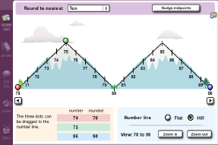
Teachers evaluate mathematics-technology integrated into lessons
In the table below (see Table 1) we present a record of the ideas that emerged from debriefing about teaching a mathematics lesson using technology in the elementary classroom. Teachers shared specific technology that they used and shared the benefits and challenges of teaching and assessing students’ learning in their technology-enhanced lesson. In developing representational fluency with teachers, we recorded the following applets that model “ten-ness”. In our discussion, we guided the teachers to reflect on their math-technology and the three domains for technology pedagogical content knowledge by using a graphic organizer chart with three columns: name of the math-technology, the math concept amplified by the tool, and the teaching strategy and assessment notes. One of the teachers used the ten frame applet and commented how after using the ten frame for the unit on addition, students were using the benchmarks numbers 5 and 10s in explaining their strategies. She commented,
“Using the ten frame to have students model addition problems have led them to group and break numbers into 5s and 10s more flexibly. For example, a student using the double ten frame to model 8+6 took 8 and made 5 and 3, and took 6 and made 5 and 1, and said that he put the 5 and 5 together to make 10 and 3 and 1 to make 4 to combine 10+4=14. Another child said, I start with 8 and take the 2 from 6 to fill the first 10 frame and take the rest 4 to make 10+4= 14. Having the visual seemed to help them break numbers a part and put them back together”
The variety and levels of tasks available on the virtual ten frame also allowed students to explore addition and subtraction strategies and allowed for differentiation through parallel tasks.
Table 1. Modeling Math with Tech-knowledgy: Modeling ten-ness
Math-Technology-Tools to represent mathematics concepts | Math Concepts Supported by the model:  Essential Understanding | Pedagogy-  Teaching Strategies & AssessmentNotes:
TEN FRAMES  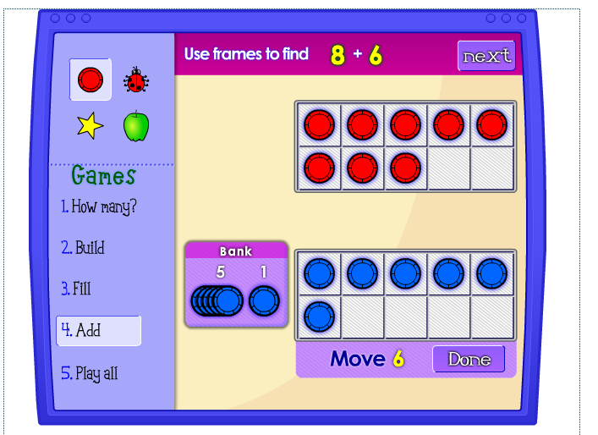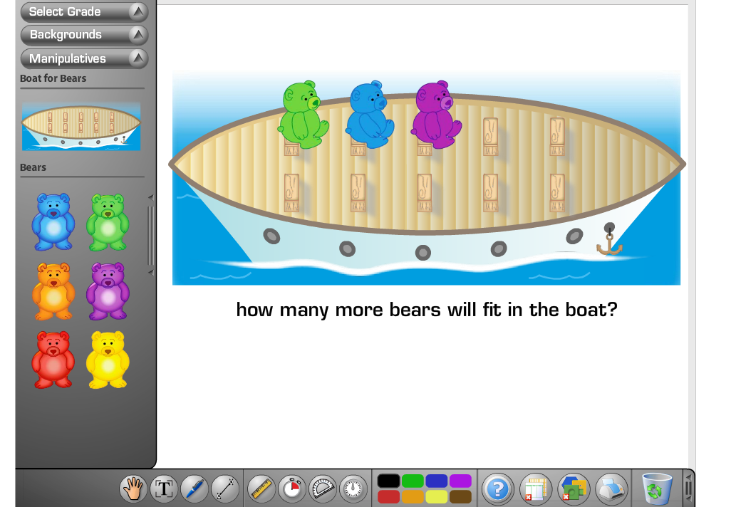  http://illuminations.nctm.org/ActivityDetail.aspx?ID=75  http://www.glencoe.com/sites/common_assets/mathematics/ebook_assets/vmf/VMF-Interface.html | Ten Frames helps students develop visual images of 10 and how that number is composed and decomposed.  The combining and separating actions in addition and subtraction models can be demonstrated using the ten frames. The site also explores building a number, filling the ten frame (by filling the missing addend) and adding two digits using a double ten frame. | “Using the ten frame to have students model addition problems have led them to group into 5s and 10s. For example, a student using the double ten frame to model 8+6 took 8 made 5 and 3 and took 6 and ‘made 5’ and 1 and said that he put the 5 and 5 together to ‘make 10’ and 3 and 1 to make 4 to combine 10+4=14. Another child said, I start with 8 and take the 2 from 6 to’fill’ the first 10 frame and take the rest 4 to make 10+4= 14. Having the visual seemed to help them break numbers a part and put them back together”.  “ The variety of tasks available on the virtual 10 frame allowed students to explore addition and subtraction strategies.”  *Also available free as a iphone and ipad app called 10 Frame Fill
BASE TEN/CHIP TRADING with PLACE VALUE MATS  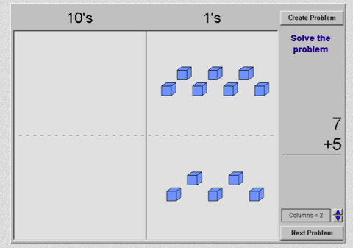  http://nlvm.usu.edu/en/nav/frames_asid_154_g_1_t_1.html  http://nlvm.usu.edu/en/nav/frames_asid_209_g_1_t_1.html  http://www.learningbox.com/base10/BaseTen.html | Place value plays a foundational role in students’ development of strategies for adding and subtracting 2-digit numbers. One can represent numbers and model composing and decomposing numbers into tens and ones.  Base-ten blocks is a proportional model in that the hundreds is ten times larger than the tens model. | The lassoing effect that glues the 10 units together always mesmerizes my students! They seem to like to see how units get grouped to make tens and how the tens get grouped together to make hundreds. Having the adjustable place value chart really helps me differentiate for students.”  “It’s a great model to model ten because it was a ‘groupable model’ where as the physical base tens are pregrouped and stuck together. The virtual manipulatives allow the user to group using the lasso.”
HUNDREDS CHART  http://standards.nctm.org/document/eexamples/chap4/4.5/index.htm | Students also work with other models, including the number line, 100 chart, and cubes organized into towers of ten. The purpose of these models is to help students build mental images that they can use in visualizing and solving problems. | “We played arrow math using the hundreds chart and modeled the actions using the calculator to connect the number sentences. Start at 38 and move⬇⬇➔➔? They counted 48,58,59,60. Students were able to see how going down meant adding (+10) going up meant (-10); right meant (+1) and left meant (-1). Then I asked them what   meant?”  “We looked at the patterns on the chart using multiples and students saw patterns with the *9 noticing it was like n*10 but (n*10)-n so 3*9 was like (3*10)-3=27.
NUMBER LINES  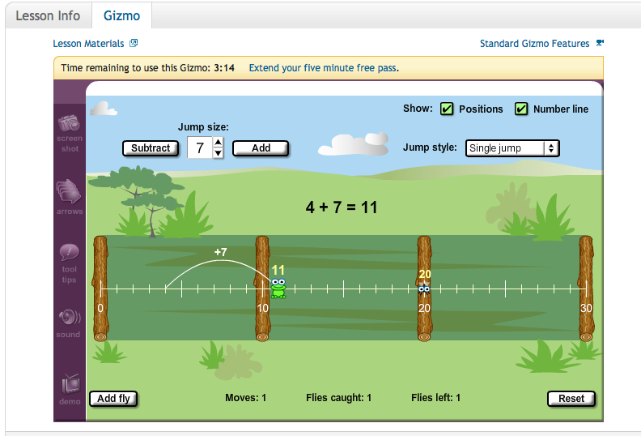http://www.explorelearning.com/ | The number line model has a lot of generality in that it has multiple uses and can be used efficiently to represent multiple operations. It can be used to develop 10-ness, addition & subtraction strategies and repeated addition or repeated subtraction to represent one of the meanings for multiplication & division. | “Using Fred the Frog engaged the students as they helped him find food by catching flies by hopping along a number line. I liked the option that the applet provided where we can hop by tens and ones or adjust the jumps. To stimulate thinking, I asked, “what is the least numbers of jumps I can use with 10s 5s and 1s?” This made them think about efficient ways to add. Or I would ask,‘How many +4 jumps do I need to get to 12?’ This got them to think of repeated addition.”
MONEY  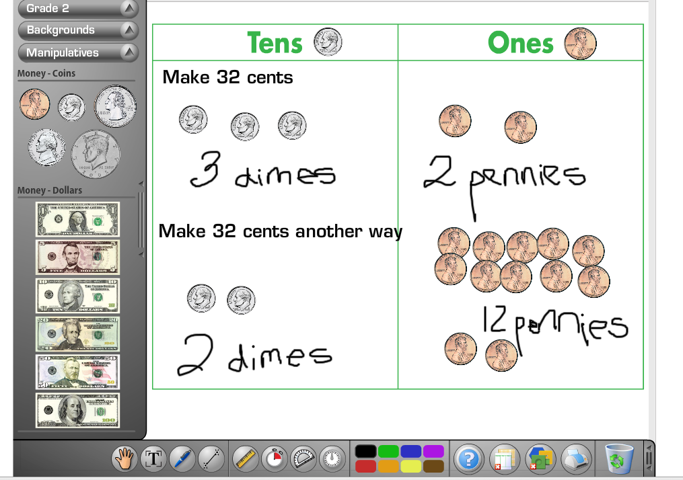 | They also work with money, focusing specifically on pennies, dimes, and dollars. They use these contexts to build and visualize how two-digit numbers are composed. | “ I used this chart to ask students to make all the combinations to buy the ice cream cone using the variety of coins. The virtual coins made it easier for students to keep an organized list of all the combination. For example, 32 cents can be composed of 3 dimes and 2 pennies or 2 dimes and 12 pennies or 1 dime and 22 pennies”
ABACUS  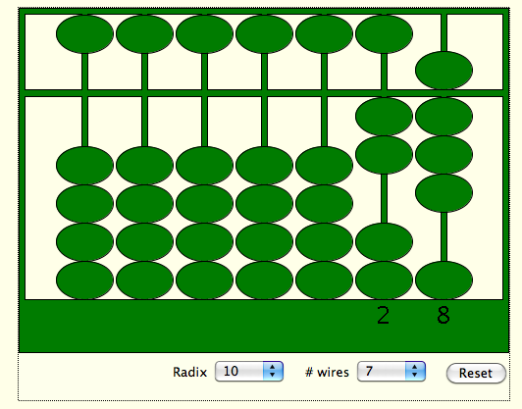  http://nlvm.usu.edu/en/nav/frames_asid_196_g_2_t_1.html?open=activities  http://www.cut-the-knot.org/Curriculum/Arithmetic/Soroban.shtml | Abacus is one of the oldest counting machine. (a technology) from the past. There are a lot of variation of abacus, including the one displayed and the Japanese soroban which has one bead on top representing 5 and the bottom beads that represent 1s. | “My second grade class was learning about ancient China and making the abacus in the class was a great social studies connection. Later we used the abacus applet to represent larger numbers and even add single digits. The idea of regrouping was a real neat connection. Students learned to go to the next rod and place 1 ten up to represent the regrouping process.”  “ I recently found a free abacus app on my iphone and ipad!”

For modeling composing and decomposing numbers, the model -Base block addition http://nlvm.usu.edu/ illustrated the concept explicitly with place value and number sense. The ten frame model from the National Council of Teachers of Mathematics Illumination Activities can be an appropriate tool for students to visualize benchmark numbers and grouping by 5’s and 10’s. One important criteria is to judge mathematical fidelity (Zbiek et. al, 2007), the degree which the actions of the technology generated representations reflect accurately the expected mathematical characteristics and behavior. An example of mathematical fidelity of the technology tool was brought up during our discussion when one teacher indicated that the “virtual base-ten applet models better the concept of composing and decomposing numbers by giving the ability to exchange and group the base blocks by dragging and lassoing.” Exploring technology with this criteria in mind, teachers became more aware of the mathematical action represented by the applet. For example, one teacher described the actions and behavior of the applet and connected it back to the mathematical actions, stating “ when a ‘long’ (ten) is dragged from the tens column into the ones column, it automatically breaks into ten-one unit pieces and (decomposes the number). When ten unit pieces are lassoed (by clicking and dragging the mouse), they automatically change into a ‘long’-ten (composing numbers)”

In addition, the Modeling Math with Tech-knowledgy activity also elicited teachers to consider the mathematics models important to teaching number sense using the proportional(base tens) versus the non-proportional models (money and abacus) and the measurement model (number line) versus composing and decomposing numbers model (base tens).
Multiple representations through technology
Technology enables students and teachers to represent concretely the abstract concepts that they are learning in mathematics class and to link these concepts to prior knowledge. One can employ proportional models (one in which 10-ness is modeled physically as ten times larger than a model for “1”). A representation of the number 42 that involves 4 tens and 2 ones is shown below. Base-10 blocks are another great example of proportional models.

While proportional models are very common, non-proportional models can exhibit multiple representations that are useful for a variety of mathematical calculations. For example consider the process of borrowing which can be modeled using chips. While one can think of 10 chips (which are all of the same size) representing 10 times one chip as a proportional model, one can also take advantage of the color of the chip to describe a non-proportional model. For example 10 red chips can represent “Ones” are traded for 1 yellow chip representing a “Tens”. This idea of multiple representations also appears in several manipulatives. For example, consider the representation of 10 on a Chinese Abacus which is shown below:
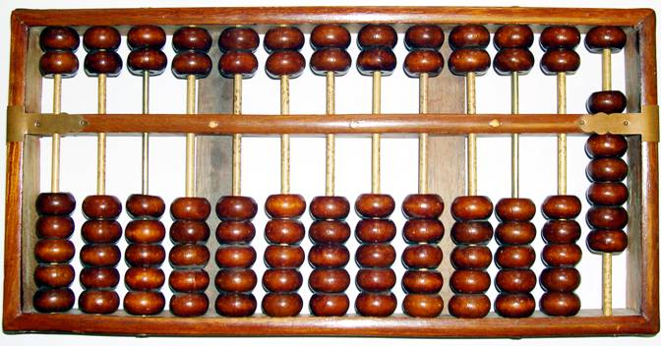
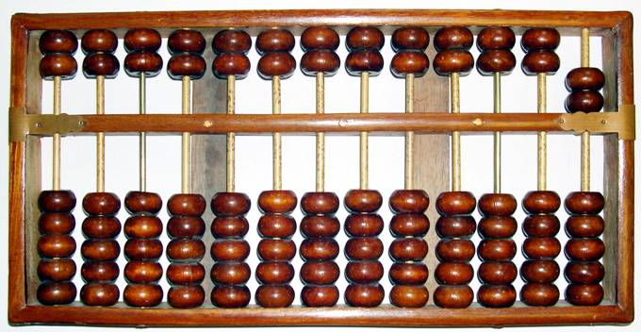
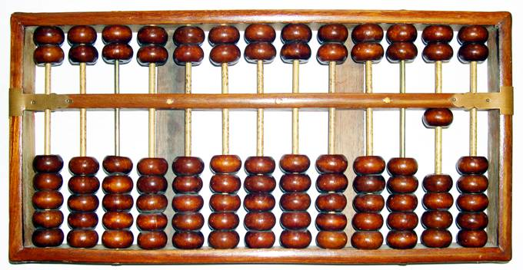

While all the beads are the same size, ten beads on the rod for “Ones” can be traded for “1” bead on the rod for “Tens”. This not only allows more flexibility in regrouping but also helps clarify misconceptions that naturally arise when subtracting with borrowing. On an another note, it is interesting that an abacus (one of the most ancient counting devices known to man kind) can represent numbers in the trillions as well as accommodate multiple ways of representing “ten” while a basic calculator (used in the modern age) can do neither of the two efficiently. This really makes us wonder as educators if newer technology really caters to enhancement of student learning? This is a good question to investigate for a future paper perhaps. However, we believe that whatever the age may be of the technology tool used whether it be a calculator or a virtual manipulative or abacus, it is important for educators to understand how to exploit the best features to enhance their teaching practices as well as improve student learning.
Teaching Mathematics with Models enhanced by Technology
The Modeling Math with Tech-knowledgy project was specifically designed to focus on three integrated knowledge domains nested in an authentic context for teaching mathematics with technology. This practice based activity for teachers also aligns with the AMTE(2007) Technology recommendation that ”appropriate experiences during their teacher preparation program in the use of a variety of technological tools to enhance their own learning of mathematics and the mathematical learning of others”. The three knowledge domains and objectives were: 1) Technology in mathematics: developing teachers’ understanding about a variety of technology tools representing multiple models and evaluating the different affordances or constraints within these technology tools; 2) Mathematics content: developing teachers mathematical understanding of the concept presented in the tools and the ability to assess the mathematical fidelity of a tool, degree to which the technology generated representations are faithful to the underlying mathematical properties (Zbiek et al, 2008); and 3) Pedagogy: developing teachers’ strategies for integrating technology in a meaningful way, determining developmental appropriateness , and mapping the instructional sequence.
With the abundance of technology resources, teachers’ new challenge is learning how to be selective in choosing the best instructional tools and creating a learning environment to effectively integrate technology for learning. Teachers need to rethink and shift their limited views of technology as a product- yielding tool to a more powerful “mind tool” to construct and represent mathematical knowledge. This implies that teachers must learn and experience for themselves how to select, evaluate, design, teach and learn using these innovative tools.
References

Association of Mathematics Teacher Educators. (2006). Preparing teachers to use technology to enhance the learning of mathematics. Retrieved from http://www.amte.net/

Koehler, M. J., & Mishra, P. (2008). What is technological pedagogical content knowledge? Contemporary Issues in Technology and Teacher Education, 9(1). Retrieved from http://www.citejournal.org/vol9/iss1/general/article1.cfm

National Council of Teachers of Mathematics (2000). Principles and Standards of School Mathematics. Reston, VA: Author.

Zbiek, R. M., Heid, M. K., Blume, G. W., & Dick, T. P. (2007). Research on technology in mathematics education: The perspective of constructs. In F. Lester (Ed.), Handbook of Research on Mathematics Teaching and Learning (pp. 1169-1207). Reston, VA: NCTM.

